

data strurcture lab

ROSHNI RAZA .61278



**Task no.01**

#include<iostream>

using namespace std;

int main(){

int n;

cout<<"enter the size of the array";

cin>>n;

int* arr=new int[n];

cout<<" enter the array elements:";

for(int i=0;i<n;i++){

cin>>arr[i];

}

int evencount=0;

int oddcount=0;

for(int i=0; i<n; i++){

if(arr[i]%2==0){

evencount++;

}

else{

oddcount++;

}

}

cout<<"even number "<<evencount<<endl;

cout<<"odd number "<<oddcount<<endl;

delete[]arr;

return 0;

}

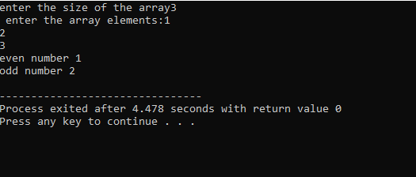

**TASK NO.02**

#include<iostream>

using namespace std;

int main(){

int n;

cout<<" enter size of array";

cin>>n;

int* arr=new int[n];

cout<<"enter the aray elements";

for(int i=0; i<n ;i++){

cin>>arr[i];

}

int maxVal=arr[0];

int minVal=arr[0];

for ( int i=1;i<n; i++){

if( arr[i]>maxVal){

maxVal=arr[i];

}

if( arr[i]<minVal){

minVal=arr[i];

}

}

cout<<" maximum value:"<<maxVal<<endl;

cout<<" manimum value:"<<minVal<<endl;

delete []arr;

return 0;

}

